Pranjal Singh

Octave Documentation

For this assignment, we had to learn how to use Octave or Matlab. I chose to recreate the plotter, salter, and smoother through Octave.

For my plotting method, I made the bounds -100 to 100. I used the same function as my other programs $y = x^{2}+13$

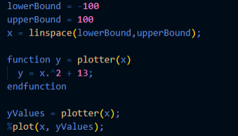

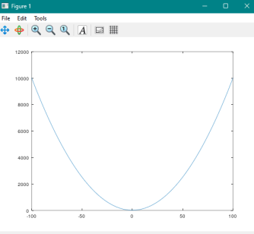

Salting

The salter works very similar to my Java program. I salted the values with the value -1000 - 1000

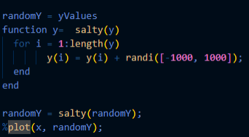

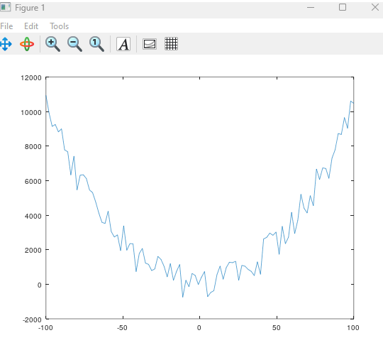

Smoothing

For the smoothing section, I implemented the same window logic as my other program. The window size above and below the point is how it gets the average. After the average is taken, it assigns it to that point. With the window of 10, This is the graphical representation

